# INTRODUCTION TO PROJECT

## Project Introduction: **OneStopShop** - Your Ultimate Laptop Destination

**Project Overview**

OneStopShop is an ambitious e-commerce platform designed to revolutionize the laptop buying experience. By offering a comprehensive and user-centric platform, we aim to become the preferred choice for consumers seeking to purchase laptops. Our platform will provide a seamless and efficient shopping journey, empowering customers to make informed decisions and find the perfect laptop to meet their unique needs.

**Problem Statement**

The current laptop market is fragmented, with numerous online retailers offering a vast array of products. This often leads to overwhelming choices for consumers, making it difficult to compare features, prices, and find the best deals. Additionally, there is a lack of reliable information and expert guidance available to assist customers in making informed purchasing decisions.

**Project Objectives**

* Create a user-friendly and visually appealing e-commerce platform that offers a wide range of laptops from various brands.
* Provide comprehensive product information, including detailed specifications, customer reviews, and expert ratings.
* Implement advanced search and filtering options to help customers find laptops that match their specific requirements.
* Offer competitive pricing and exclusive deals to attract customers and build loyalty.
* Provide secure and convenient payment and shipping options.
* Deliver exceptional customer support through multiple channels (live chat, email, phone).
* Utilize data analytics to understand customer behavior and preferences, enabling personalized recommendations and targeted marketing campaigns.

**Target Audience**

Our primary target audience includes:

* Students and young professionals seeking laptops for academic and work purposes.
* Gamers and content creators requiring high-performance laptops.
* Business professionals needing laptops for productivity and mobility.
* Individuals looking for affordable yet reliable laptops.

**Project Scope**

The project scope encompasses the development of a robust e-commerce platform, including:

* Front-end development for a visually appealing and intuitive user interface.
* Back-end development for product management, inventory control, order processing, and payment integration.
* Integration with payment gateways and shipping carriers.
* Development of a content management system for product information and marketing materials.
* Implementation of a robust search and filtering system.
* Integration of customer reviews and ratings.
* Development of a customer support system.
* Implementation of data analytics and reporting tools.

By addressing the challenges faced by laptop buyers and providing a superior shopping experience, OneStopShop aims to establish itself as a leading player in the e-commerce market.

**Would you like to add anything else to this introduction?**

**2.REQUIREMENTS**

**2.1 FUNCTIONAL REQUIREMENTS**

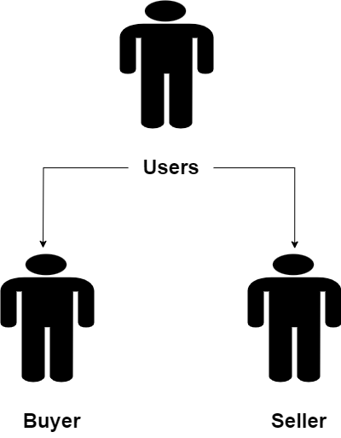

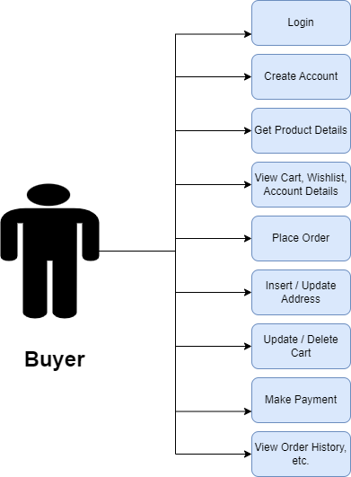

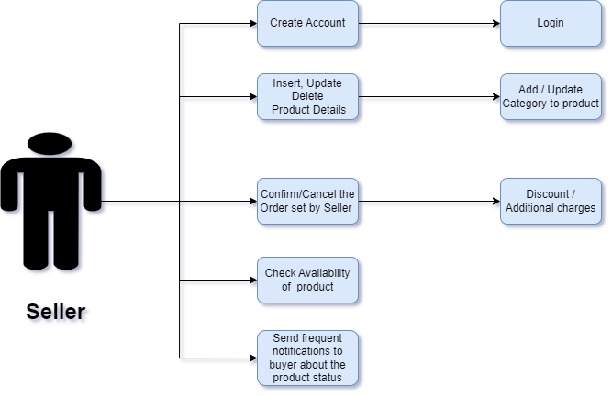

**Key Features:**

**Effortless Shopping with Unmatched Security**

This website is designed to be your one-stop shop for everything you need. We offer a **seamless and secure e-commerce experience**, empowering you to browse and purchase a vast array of products with ease.

**Explore Without Limits:**

* **Guest Browsing:** Dive right in! You don't need an account to explore our extensive product categories. Browse through electronics, fashion, home appliances, and more. Filter by price and availability to find exactly what you're looking for.

**Shop with Confidence:**

* **Secure Account Management:** When you're ready to take the plunge, creating an account is a breeze. We prioritize your safety with a secure signup process and top-notch encryption to safeguard your login credentials.

**A Shopping Experience You'll Love:**

* **Enhanced Shopping Flow:** From browsing through our meticulously curated product selection to adding items to your cart and checking out, the entire process is designed for ultimate convenience.

**Informed Decisions, Every Time:**

* **Detailed Product Reviews:** Make confident purchases with access to comprehensive product information. Read detailed descriptions and reviews from other customers before finalizing your order. You can also add or edit shipping addresses as needed to ensure smooth delivery.

**A Platform for Everyone:**

* **Multiple User Types:**
  + **Buyers (End Users):** Enjoy a secure and comprehensive shopping experience with features like secure transactions and easy account management.
  + **Sellers (Separate Login):** Manage your business effectively with a dedicated seller portal. Add, update, and delete product listings with ease, ensuring all relevant data is included.

This website goes beyond just selling products; it provides a secure and user-friendly environment for both buyers and sellers to thrive.

## Understanding the Requirements

**Before we proceed, let's clarify a few points:**

* **Project Domain:** The original text appears to be related to an airline reservation system. Is this correct?
* **Specific Requirements:** Are there any specific requirements or functionalities you want to prioritize or exclude in the new content?
* **Target Audience:** Who is the intended audience for this content? Technical developers, project managers, or stakeholders?

## Proposed Revised Content

**Assuming the project domain is an airline reservation system and the target audience is technical developers or project managers, here's a revised version:**

### 2.1 User Account Management

**User Roles and Permissions:**

* **Guest User:**
  + Can view flight schedules, availability, and pricing.
  + Cannot make bookings or manage personal information.
* **Registered User:**
  + Can perform all actions available to a guest user.
  + Can create and manage bookings.
  + Can view and modify personal information.
  + Can access additional features (e.g., loyalty program, special offers).

**User Authentication:**

* Users will be authenticated using a combination of username and password.
* The system will implement robust password hashing and salting mechanisms to protect user credentials.
* Guest users will be assigned a temporary session ID for tracking purposes.

**User Interface:**

* The system will provide a clear and intuitive interface for users to manage their accounts, including:
  + Profile viewing and editing
  + Password change
  + Booking history
  + Communication preferences

### 2.2 User Registration

**Required User Information:**

* Username (unique identifier)
* Password
* First name
* Last name
* Email address
* Contact phone number
* Date of birth
* Address (optional)
* Preferred language (optional)
* Emergency contact information (optional)

**Data Validation:**

* All user-provided data will be validated to ensure accuracy and consistency.
* The system will enforce data format and length restrictions.
* Email addresses will be verified through a confirmation process.

**Data Storage:**

* User information will be securely stored in a database.
* Personal identifiable information (PII) will be encrypted at rest and in transit.
* Access to user data will be restricted to authorized personnel.

**Additional Considerations:**

* Consider implementing a user profile completion incentive to encourage users to provide more information.
* Allow users to import contact information from external sources (e.g., Google Contacts).
* Provide options for social login (e.g., Facebook, Google) for faster registration.

**Would you like to focus on a specific aspect of user accounts or registration?** For example, we could delve deeper into security measures, user experience design, or data privacy considerations.



## Understanding the Requirements

**Project Domain:** Airline Reservation System (ARS) **Focus Area:** Booking, confirmation, and user management

### Revised Content

#### 2.3 Booking and Confirmation

**Booking Process:**

* **Guest Users:** Must register before making a booking.
* **Registered Users:** Can book directly if logged in; otherwise, must log in first.
* **Booking Availability:**
  + For departures within 2 weeks, only immediate purchase is allowed.
  + For departures beyond 2 weeks, both booking and purchase options are available.
  + Bookings are subject to availability and will decrement the number of available seats.
* **Payment:**
  + Credit/debit card information is required for purchase.
  + Payment processing integration will be implemented (not detailed here).
* **Booking Confirmation:**
  + Upon successful booking or purchase, the system will generate a confirmation number.
  + An email confirmation will be sent to the user.

**Booking Data:**

* Booking information (passenger details, flight details, fare, etc.) will be stored in the DB-reservation database.
* A relationship between the user and the booking will be maintained (e.g., using a foreign key).

#### 2.4 Booking History

* Registered users can view their booking history using their booking or confirmation number.
* The system will retrieve booking details from the UserBookingTable and present them in a user-friendly format.

#### 2.5 Admin Module

* Admin users will have access to a dedicated interface for managing airline and flight information.
* Admin functionalities include:
  + Adding/editing/deleting airlines
  + Adding/editing/deleting flights
  + Viewing user information (read-only)

### 2.2 Non-Functional Requirements

**Performance:**

* The system should be able to handle a minimum of 1000 transactions per second.
* Load testing will be conducted to assess system performance under peak loads.
* Redundancy and failover mechanisms will be implemented to ensure system availability.

**Security:**

* User data (especially payment information) will be encrypted both at rest and in transit.
* Access controls will be implemented to protect sensitive data.
* Regular security audits and vulnerability assessments will be performed.

**Usability:**

* The user interface will be designed to be intuitive and user-friendly.
* User testing will be conducted to gather feedback on usability.
* Accessibility standards will be considered for users with disabilities.

**Other Requirements:**

* System hardware and software specifications will be defined based on project requirements and budget.
* Compatibility with different browsers and operating systems will be ensured.

**Note:**

* This outline provides a high-level overview of the project.
* Detailed design and implementation specifications will be developed in subsequent project phases.
* Additional requirements and functionalities may be added based on further analysis and stakeholder input.

**3. DESIGN**

**3.1 Database Design**

The following table structures depict the database design.

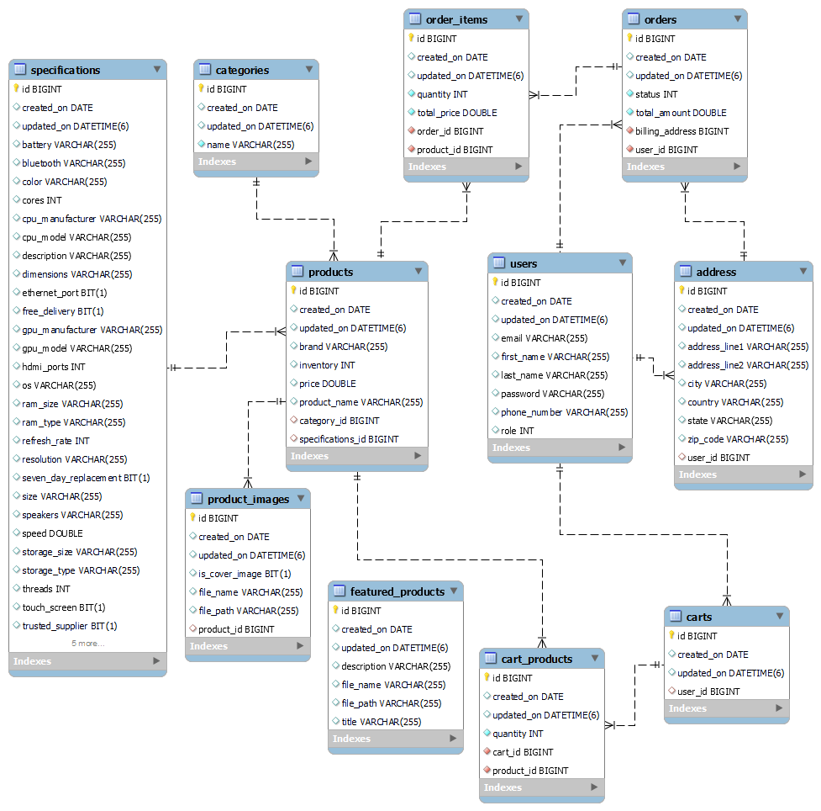

**4. CODING STANDARDS IMPLEMENTED**

### Naming and Capitalization

Below summarizes the naming recommendations for identifiers in Pascal casing is used mainly (i.e. capitalize first letter of each word) with camel casing (capitalize each word except for the first one) being used in certain circumstances.

|  |  |  |  |
| --- | --- | --- | --- |
| **Identifier** | **Case** | **Examples** | **Additional Notes** |
| Class | Pascal | Person, BankVault, SMSMessage, Dept | Class names should be based on "objects" or "real things" and should generally be **nouns**. No ‘_’ signs allowed. Do not use type prefixes like ‘C’ for class. |
| Method | Camel | getDetails, updateStore | Methods should use **verbs** or verb phrases. |
| Parameter | Camel | personName, bankCode | Use descriptive parameter names. Parameter names should be descriptive enough that the name of the parameter and its type can be used to determine its meaning in most scenarios. |
| Interface | Pascal with "I" prefix | Disposable | Do not use the ‘_’ sign |
| Property | Pascal | ForeColor, BackColor | Use a noun or noun phrase to name properties. |
| Associated private member variable | _camelCase | _foreColor, _backColor | Use underscore camel casing for the private member variables |
| Exception Class | Pascal with "Exception" suffix | WebException, |  |

### Comments

* Comment each type, each non-public type member, and each region declaration.
* Use end-line comments only on variable declaration lines. End-line comments are comments that follow code on a single line.
* Separate comments from comment delimiters (apostrophe) or // with one space.
* Begin the comment text with an uppercase letter.
* End the comment with a period.
* Explain the code; do not repeat it.

**5. TEST REPORT**

**Another group called Linux did the testing and the report of the testing is given hereunder.**

**GENERAL TESTING:**

|  |  |  |  |  |
| --- | --- | --- | --- | --- |
| **SR-NO** | **TEST CASE** | **EXPECTED RESULT** | **ACTUAL RESULT** | **ERROR MESSAGE** |
| 1 | Register Page | Redirected to Next page | OK | Nothing |
| 2 | Login Page | Pop-up will come | Ok | Please enter username and password again . |
| 3 | Reset login | Only users password will be reseted | Ok | Nothing |
| 4 | Quick search Products | Gives all product details | Ok | Nothing |
| 5 | Orders | All the fields should be filled for submission | Ok | Nothing |
| 6 | Checking login or not | User is logged in or not | Ok | Nothing |
| 7 | Add person details for order | Add informations according to no of seats allocated | Ok | Nothing |
| 8 | Goto ticket page | Set added information about person | Ok | Nothing |
| 9 | Add information in orders table | Save this all data into orders table | Ok | Nothing |
| 10 | Transaction | On back it should be reverted to previous page | Ok | Nothing |
| 11 | View transaction done | It shows you all transactions done previously | Ok | Nothing |
| 12 | Logout | It will logout from user profile. | Ok | Nothing |
|  | **STATIC TESTING** |  |  |  |
| **SR-NO** | **Deviation** | **Program** |  |  |
| 1 | Commenting not followed | All Web Application |  |  |

**Goal:** Convert a traditional project management table (with dates, tasks, phases, and notes) into a format suitable for an e-commerce laptop website project.

**Challenges:**

* The provided table is very detailed and specific to a different project.
* E-commerce projects have unique phases and tasks compared to software development.
* We need to focus on key milestones and deliverables for an e-commerce laptop website.

## Proposed Project Management Table for E-commerce Laptop Website

**Note:** This table provides a general outline. Specific tasks and timelines will vary based on project scope, resources, and complexity.

|  |  |  |  |
| --- | --- | --- | --- |
| **Date** | **Work Performed** | **Project Phase** | **Additional Notes** |
| [Start Date] | Project Initiation & Planning | Project Initiation | Define project scope, goals, and objectives. Identify target market and competitors. |
| [Date] | Market Research & Competitor Analysis | Project Planning | Conduct in-depth market research to understand customer needs and preferences. Analyze competitor websites. |
| [Date] | Website Requirements Gathering | Project Planning | Define website features, functionalities, and content requirements. Create wireframes and mockups. |
| [Date] | Technology Selection | Project Planning | Choose e-commerce platform (e.g., Shopify, Magento, WooCommerce), hosting, and payment gateway. |
| [Date] | Team Formation & Roles | Project Planning | Assemble project team with necessary skills (design, development, marketing, etc.). Define roles and responsibilities. |
| [Date] | Project Timeline & Budget Creation | Project Planning | Develop a detailed project timeline and budget. Allocate resources accordingly. |
| [Date] | Website Design & Development | Design & Development | Create website design, including layout, color scheme, and branding elements. Develop website structure and content. |
| [Date] | Product Catalog Creation | Design & Development | Import product data, create product descriptions, images, and pricing. Optimize product pages for search engines. |
| [Date] | E-commerce Functionality Development | Design & Development | Implement shopping cart, checkout process, payment gateway integration, and order management system. |
| [Date] | Website Testing & Quality Assurance | Testing & Deployment | Conduct thorough testing to identify and fix bugs. Ensure website performance and security. |
| [Date] | Website Launch & Marketing | Launch & Marketing | Launch the website and implement marketing strategies (SEO, PPC, social media, email marketing). |
| [Date] | Post-Launch Analysis & Optimization | Ongoing | Monitor website performance, collect customer feedback, and make necessary improvements. |

Export to Sheets

**Additional Considerations:**

* **Agile Methodology:** Consider using an Agile approach with sprints for iterative development and flexibility.
* **Project Management Tools:** Utilize project management software (e.g., Trello, Asana) to track progress and collaborate effectively.
* **Risk Management:** Identify potential risks and develop mitigation plans.
* **Communication:** Establish clear communication channels among team members and stakeholders.

By adapting this table to your specific project requirements, you can effectively manage the development of your e-commerce laptop website.

Appendix A

Entity Relationship Diagram



Homepage: 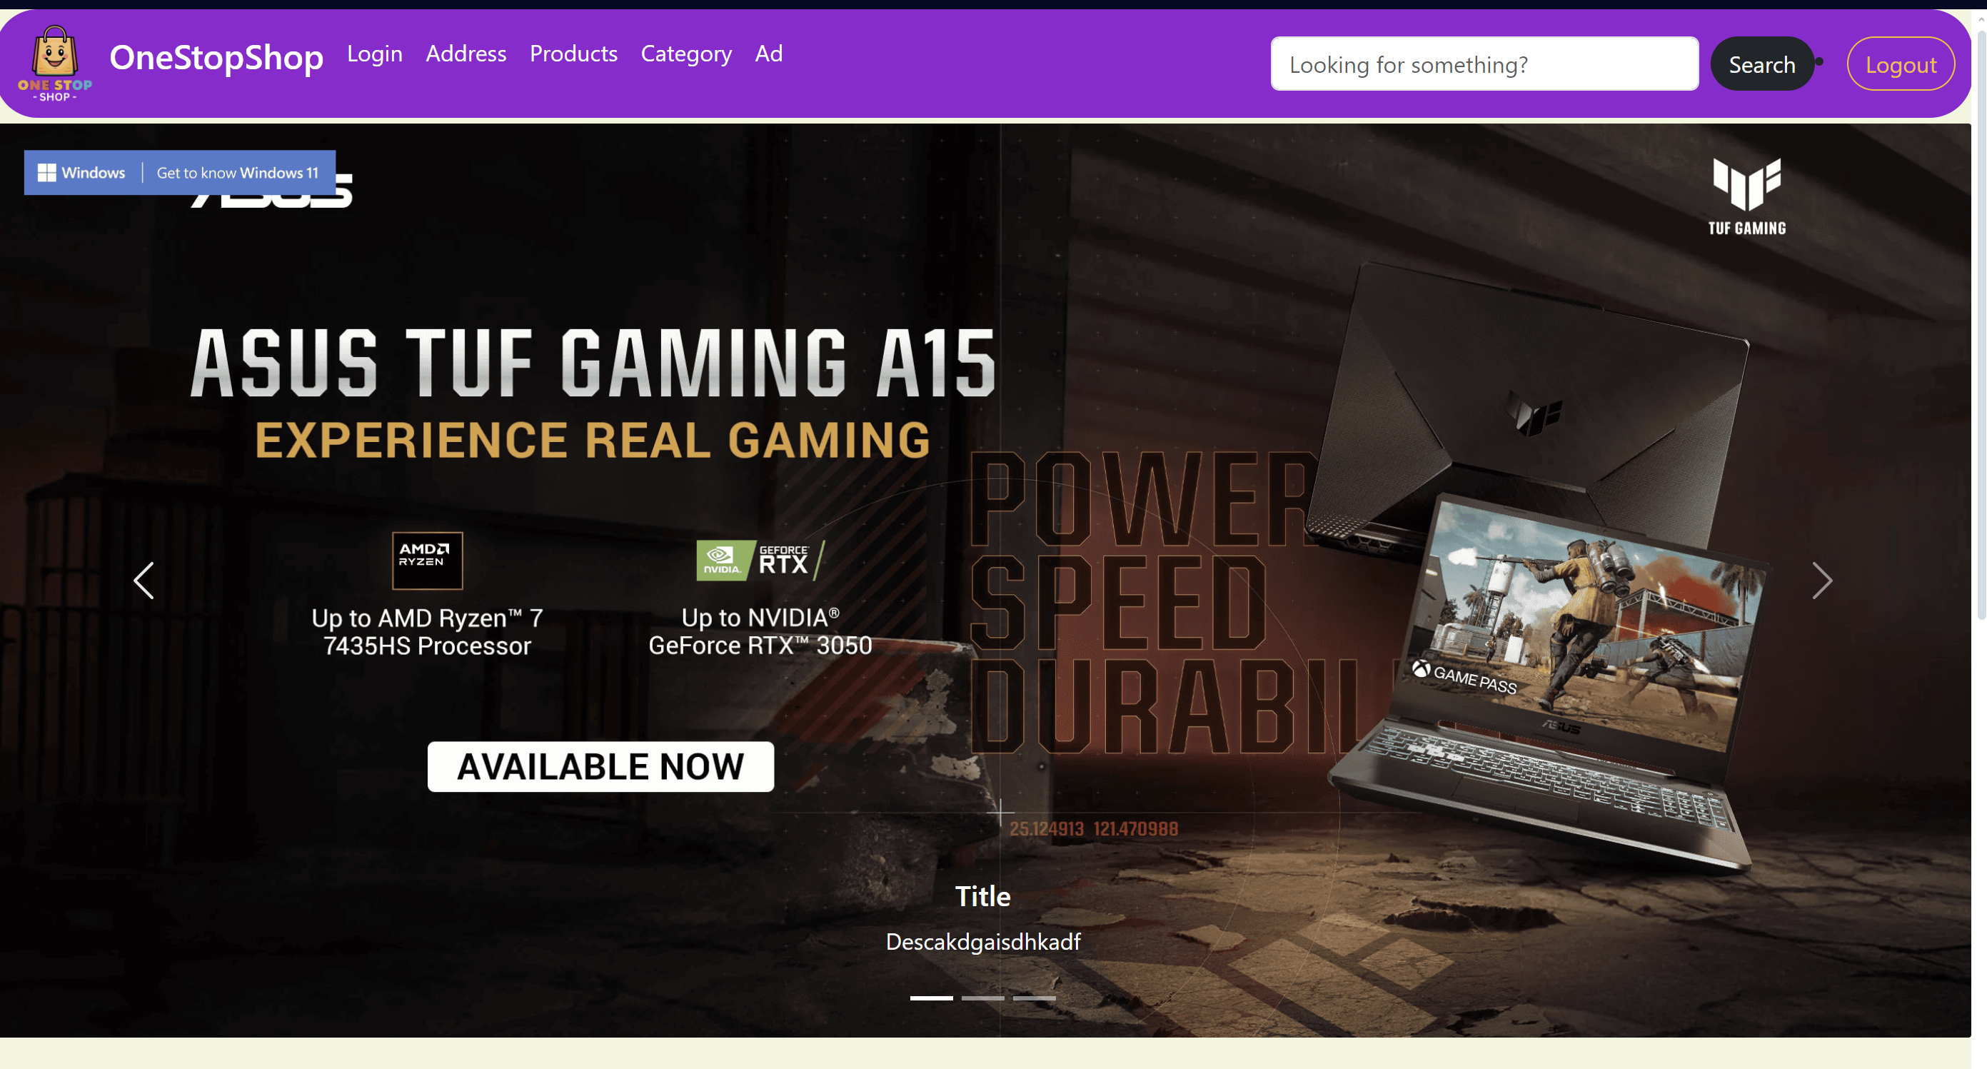

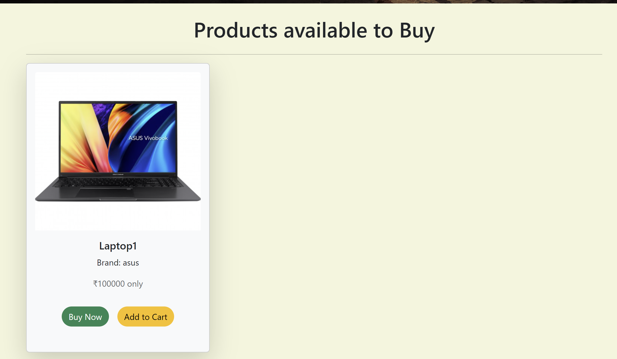

LoginPopup: 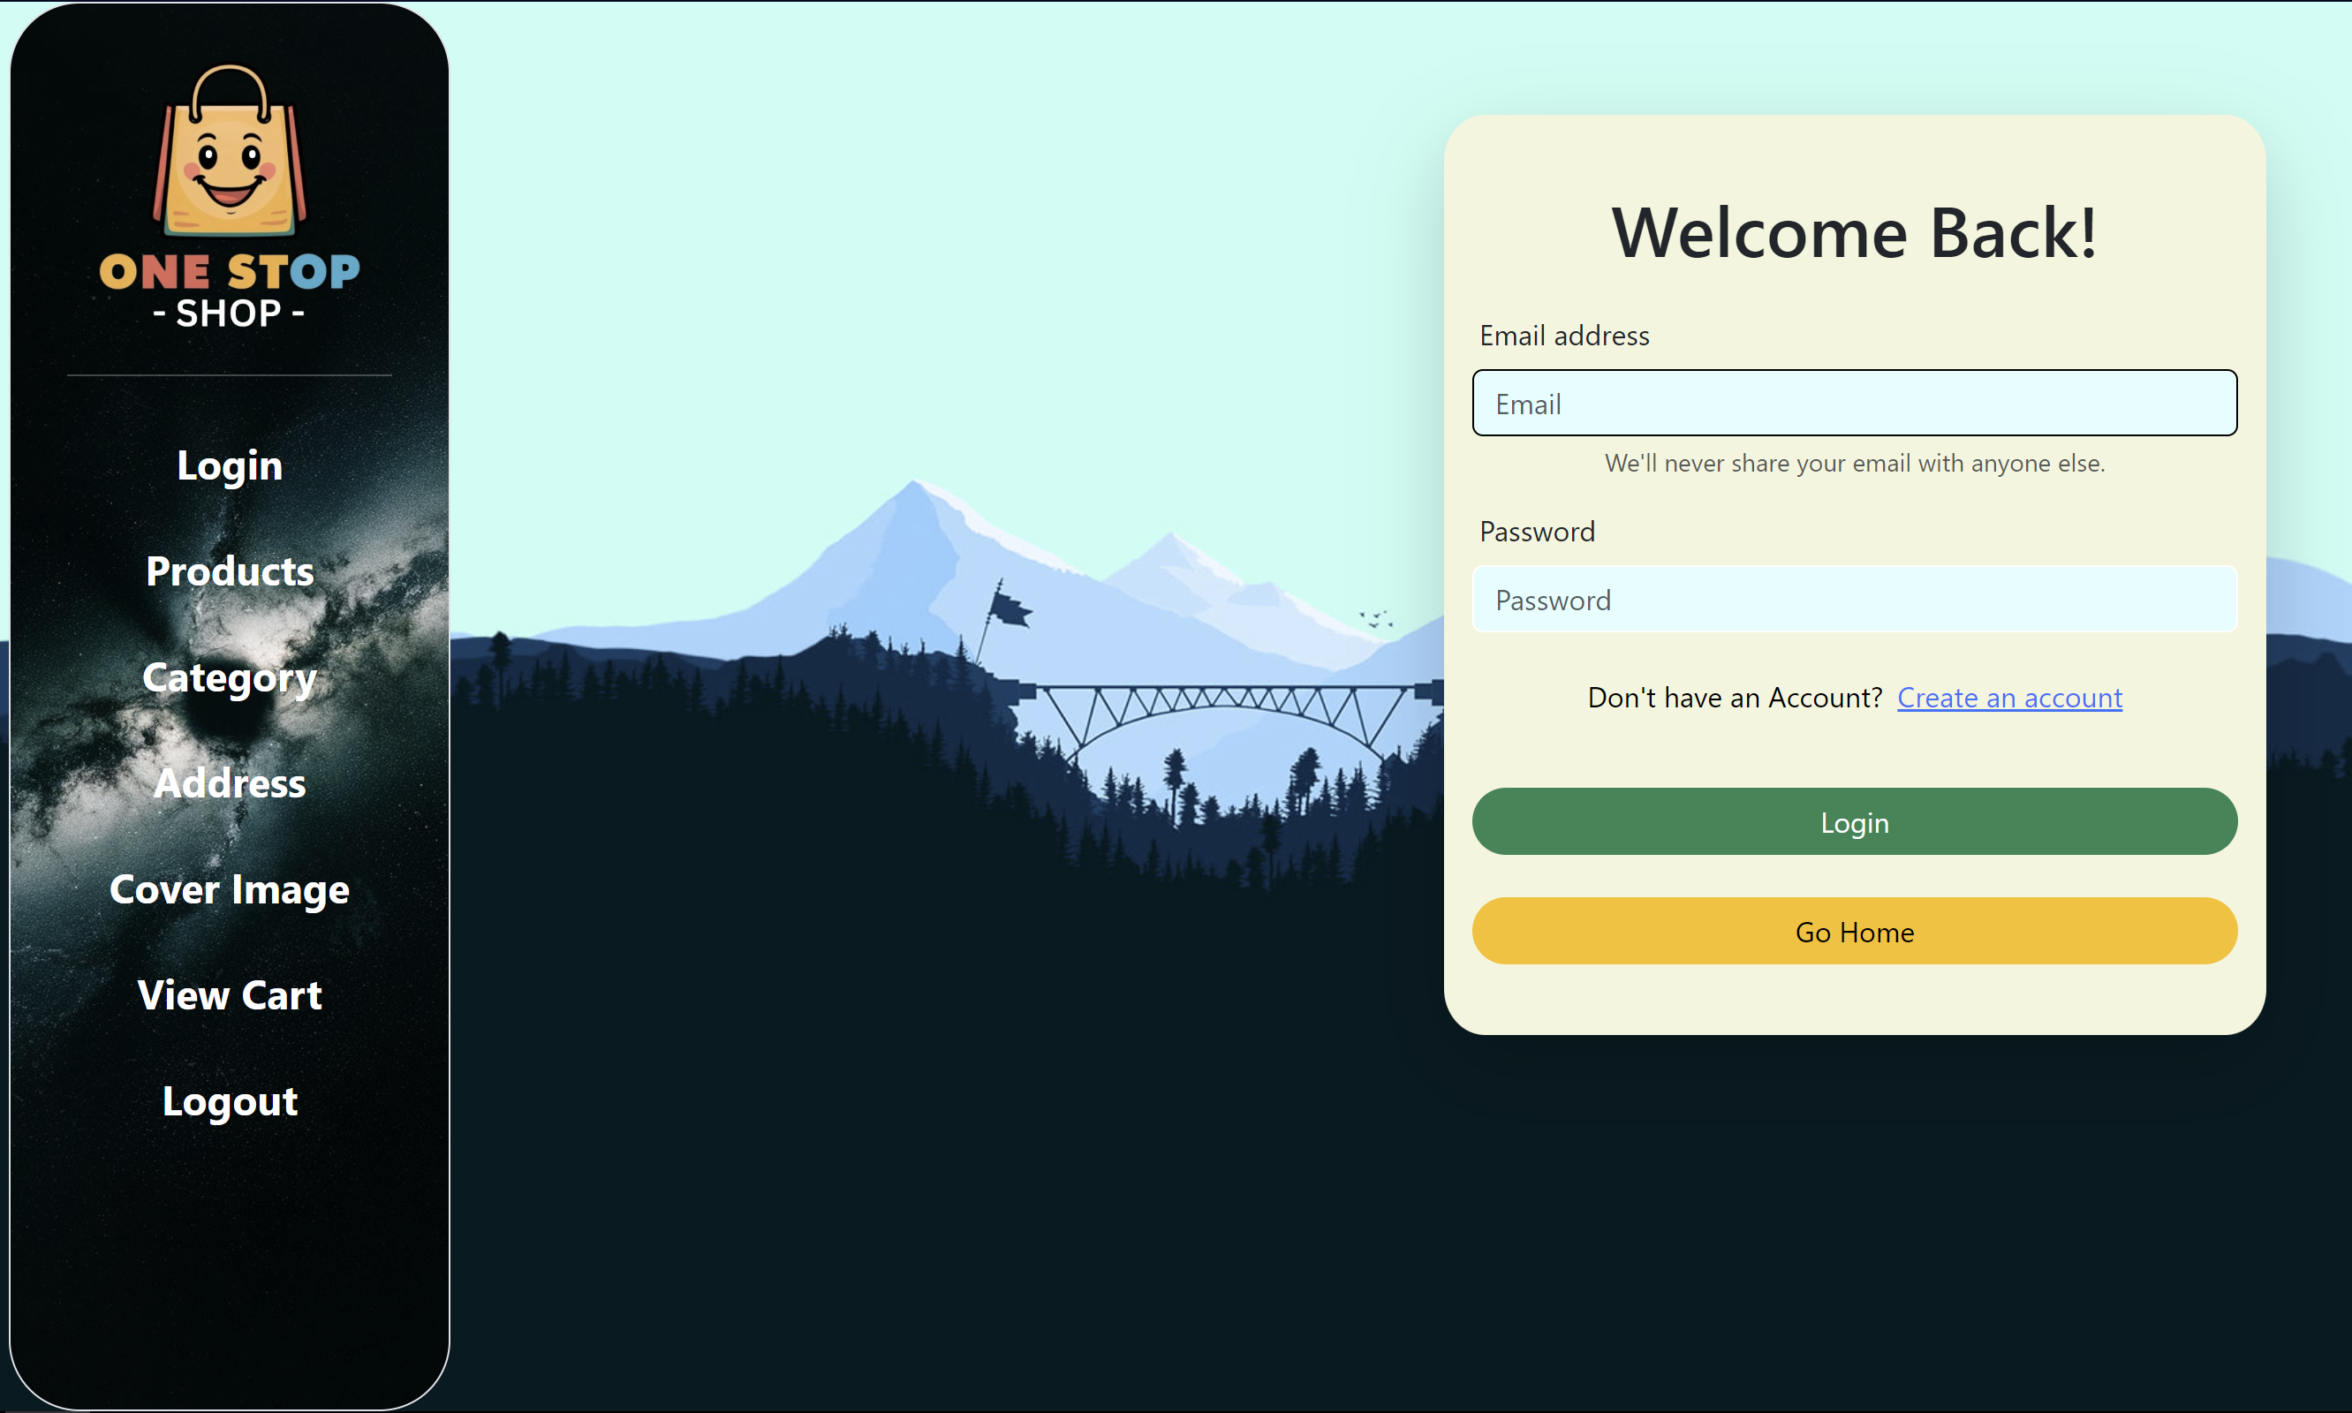

User Registration:

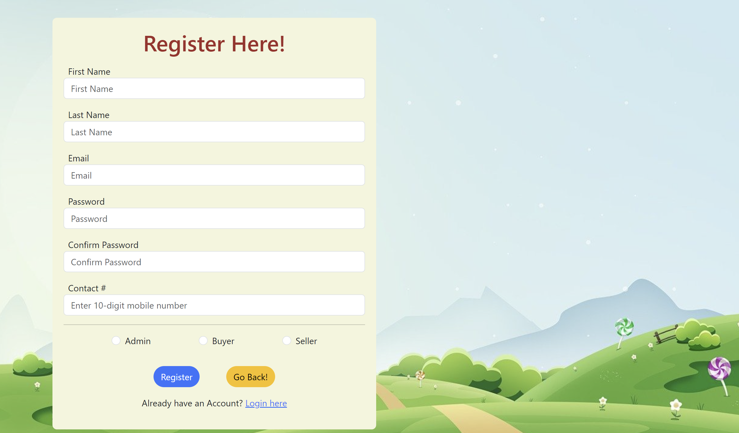

**Add Products**

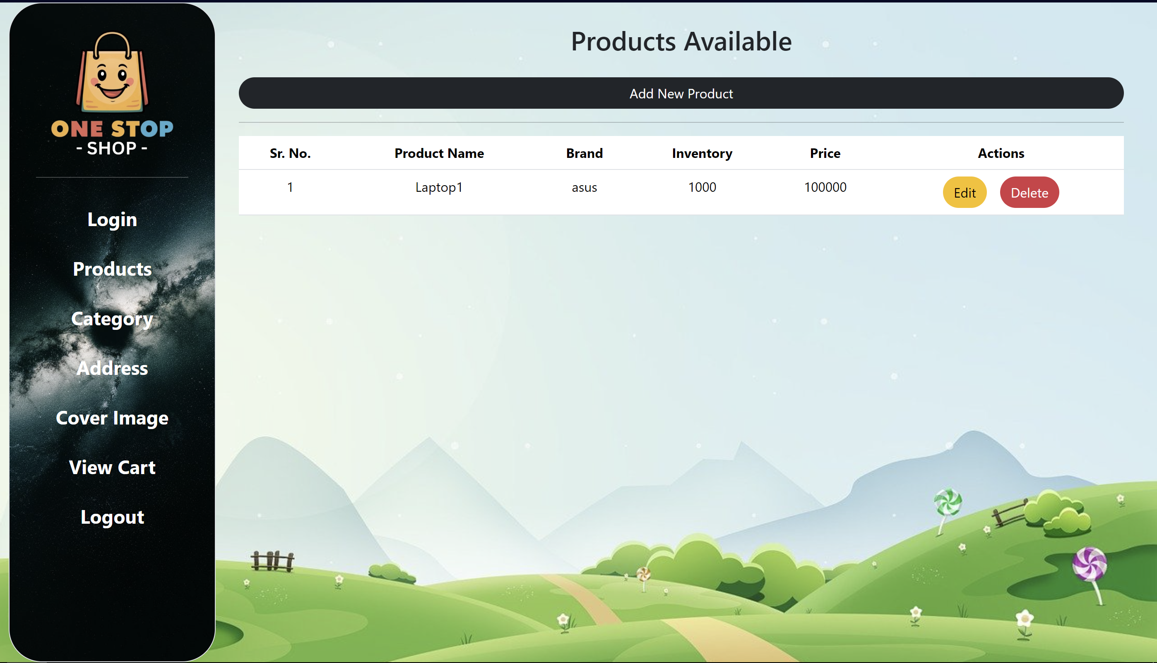

**AddFlight**

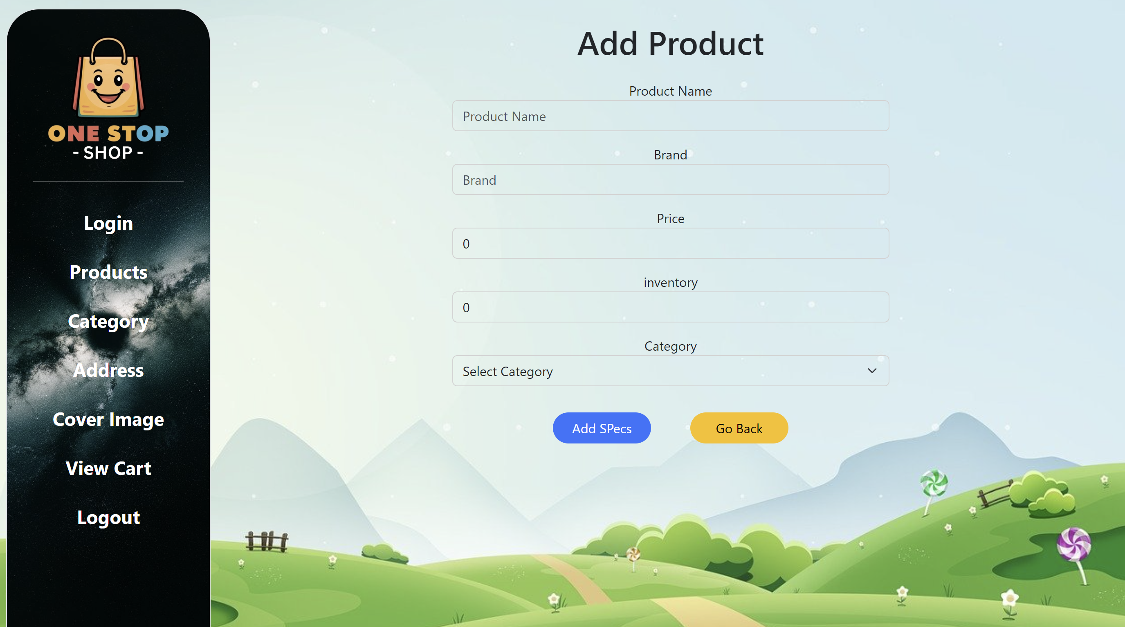

**Add Specifications**

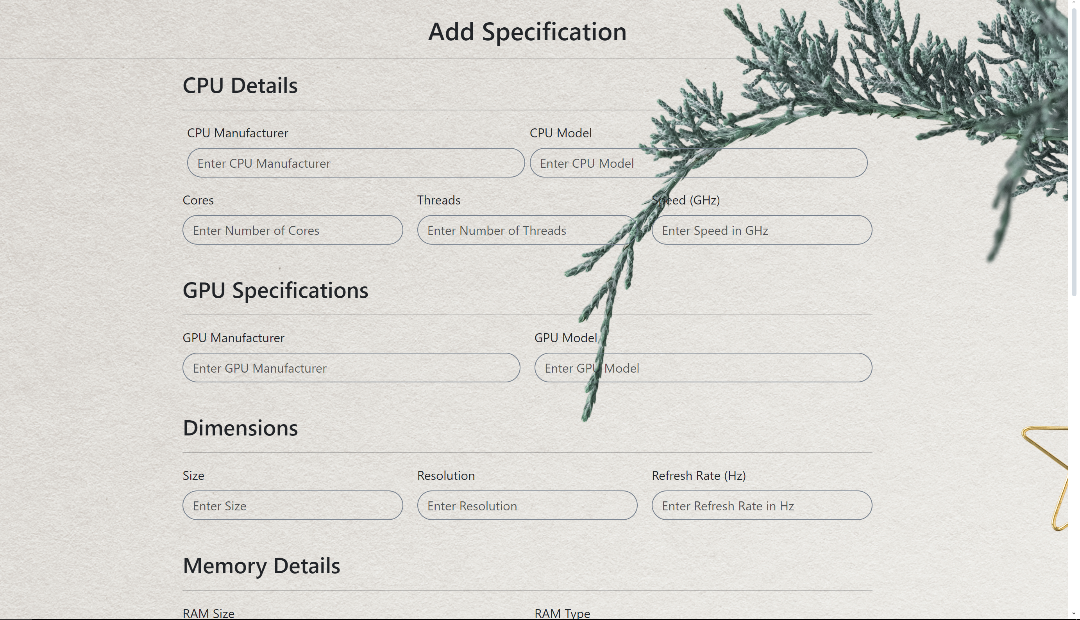

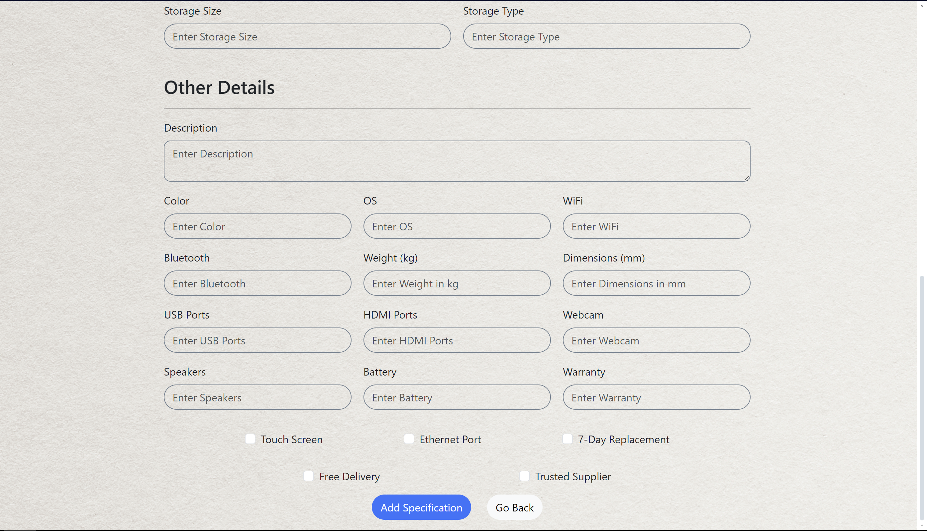

**QuickFlightSearch:**

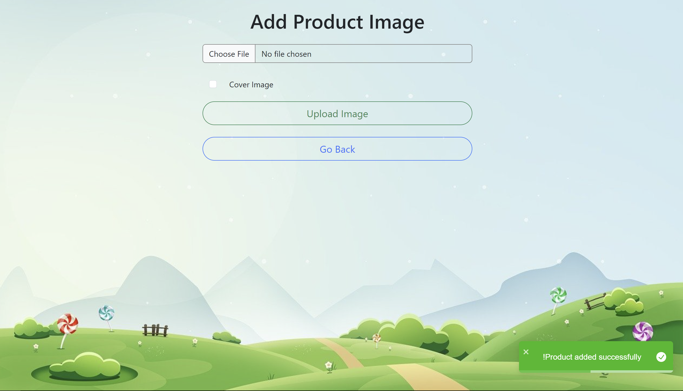

LoginForBooking:

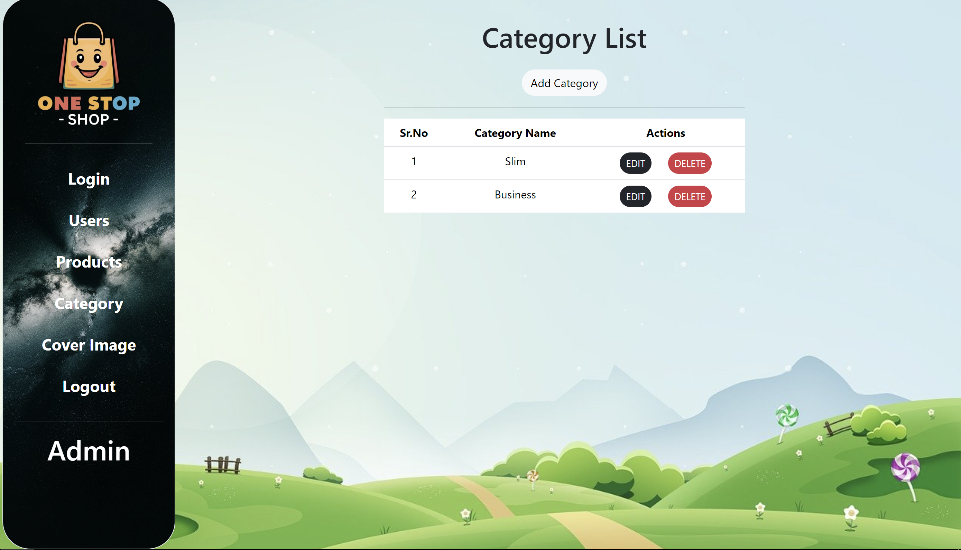

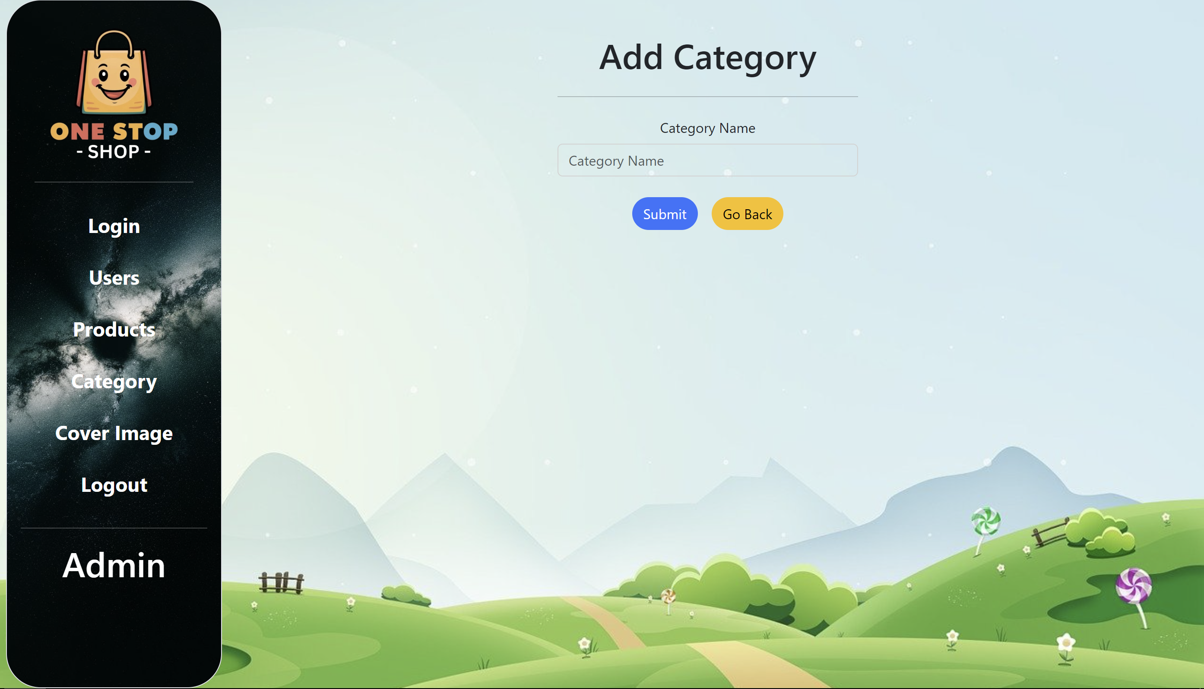

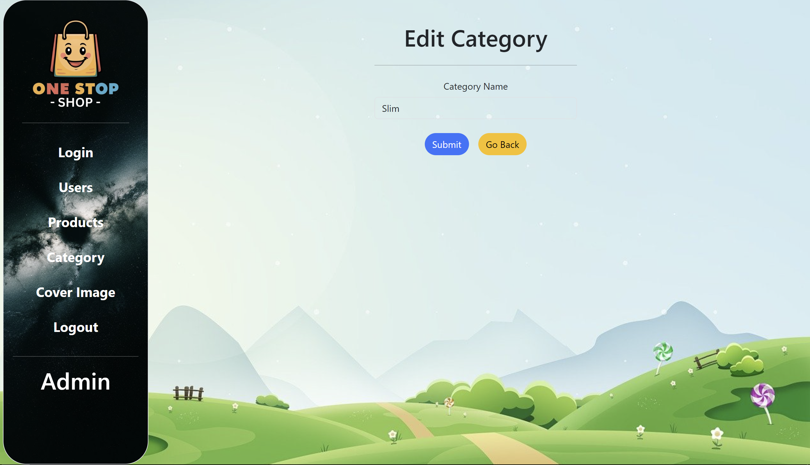

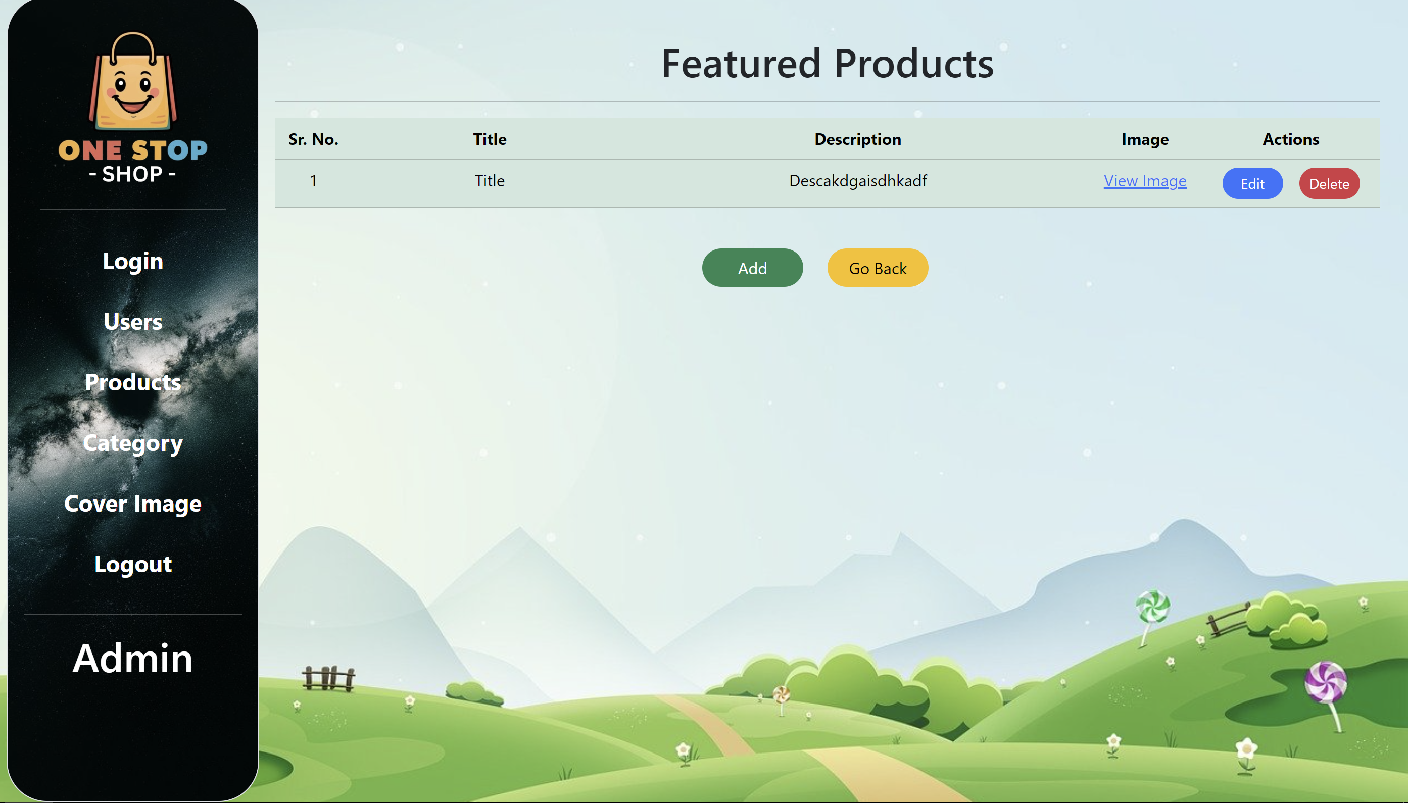

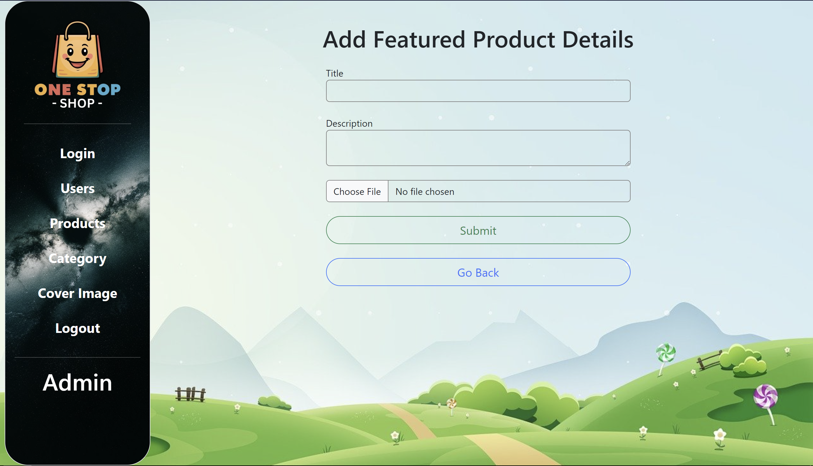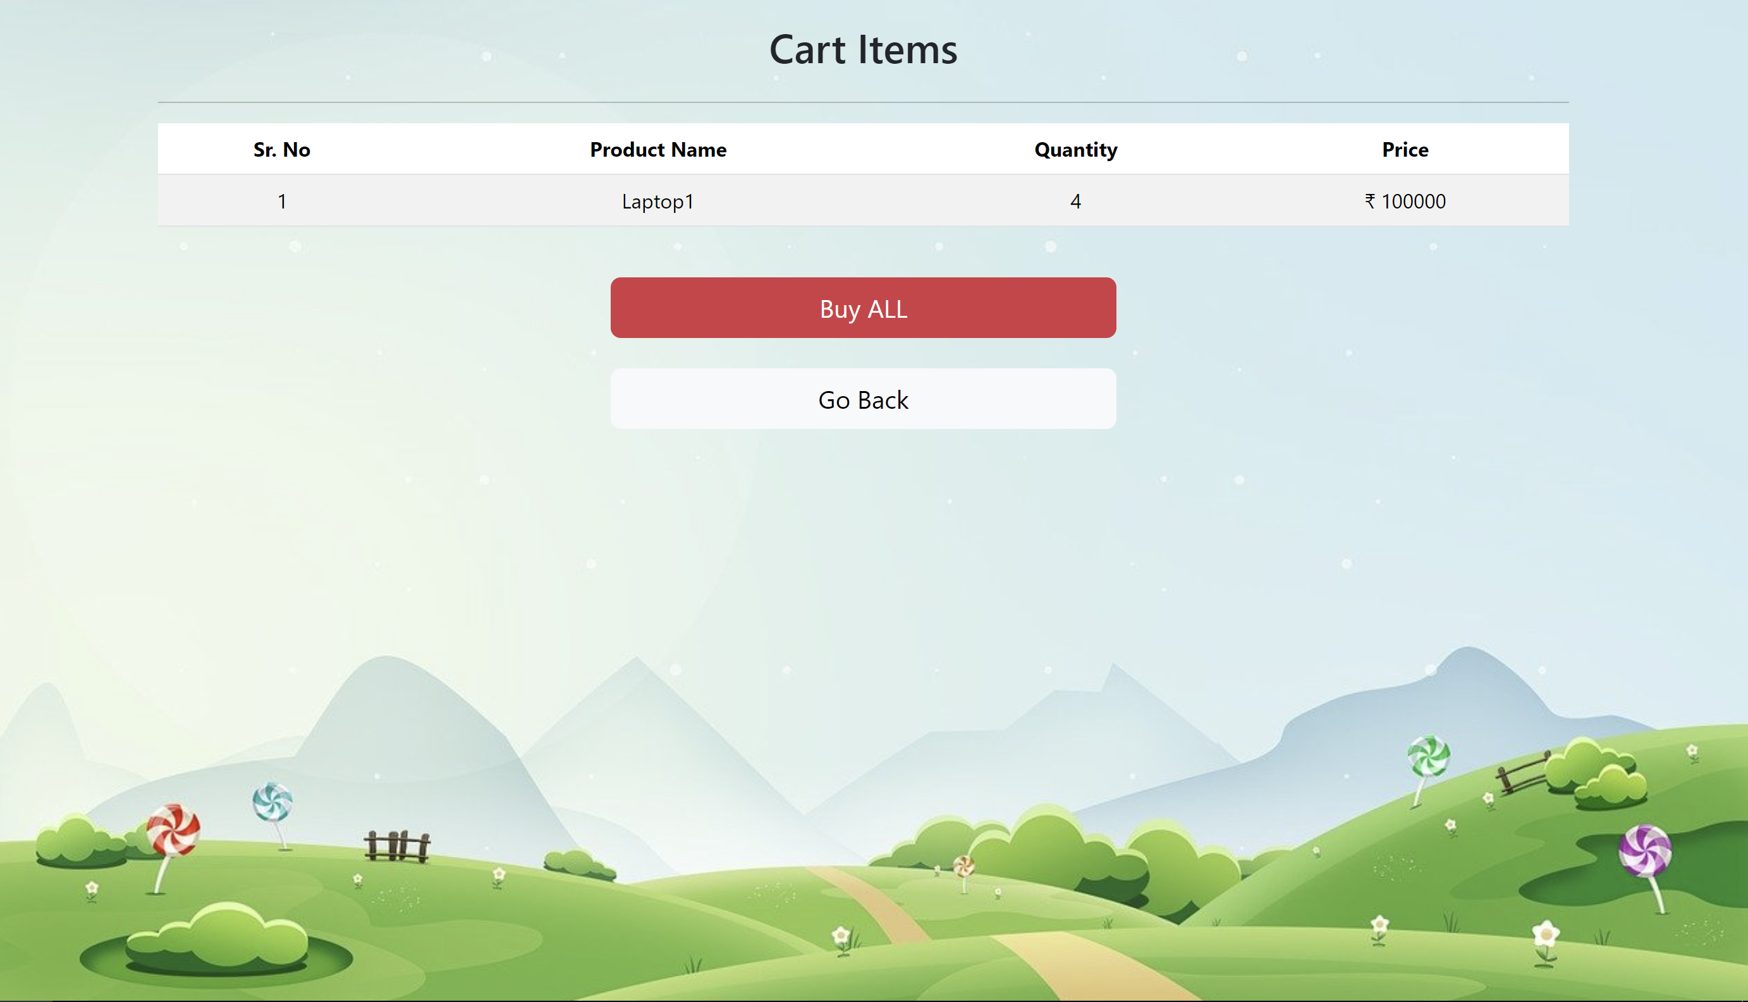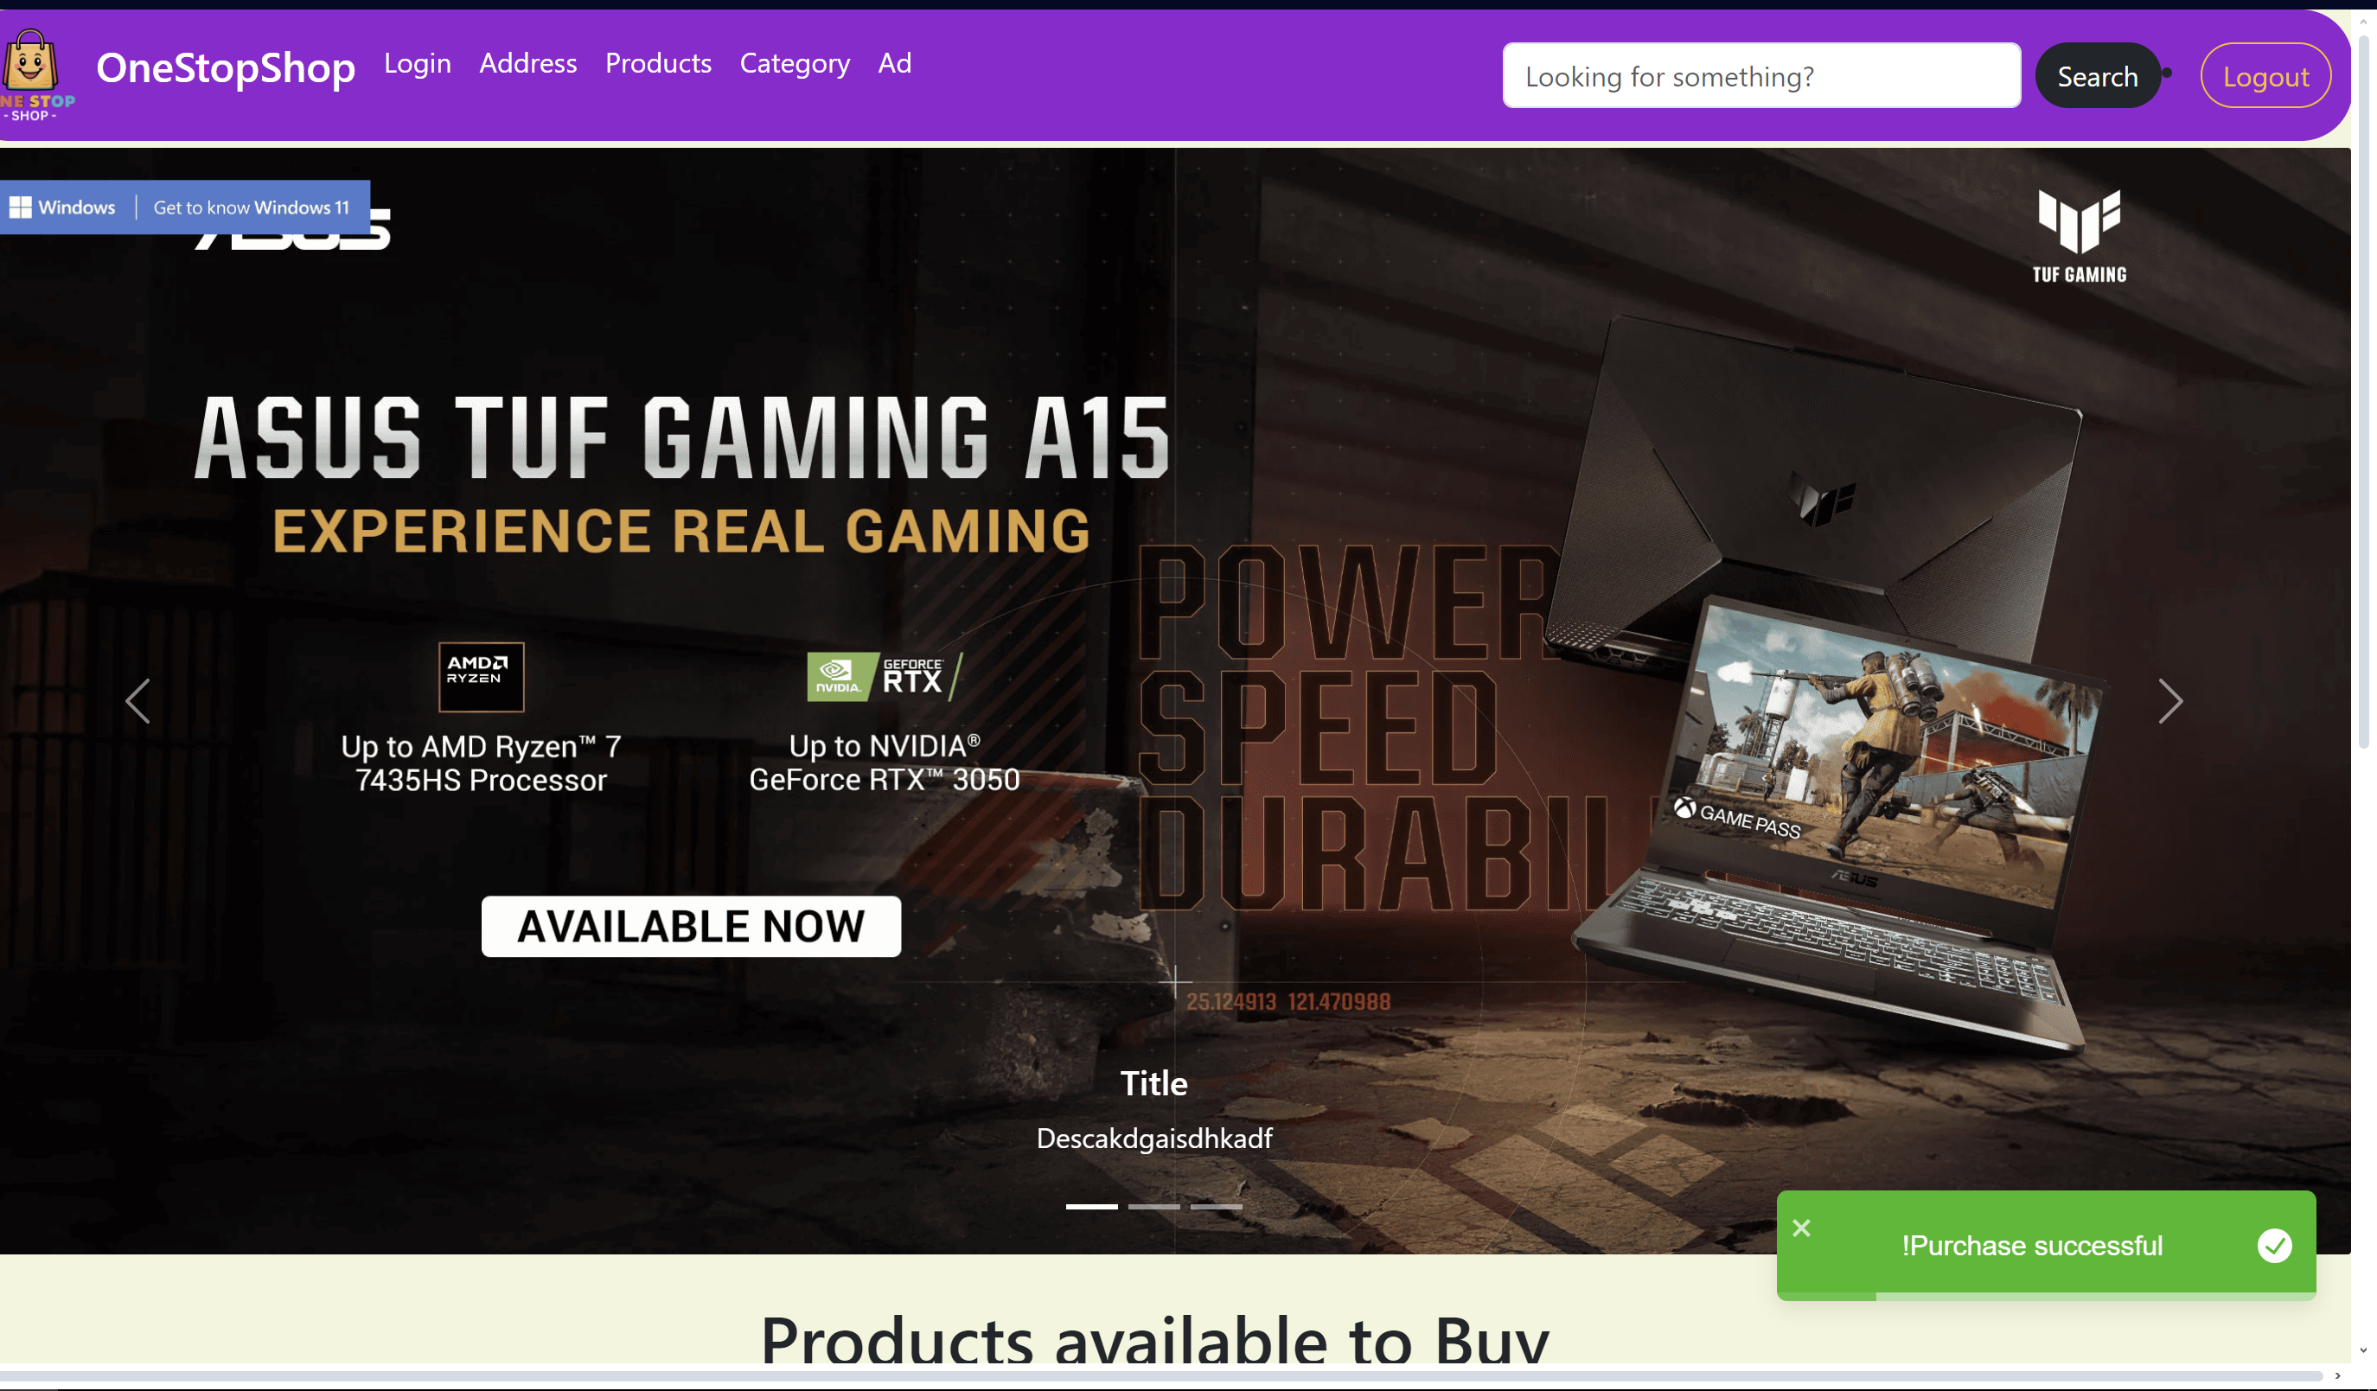

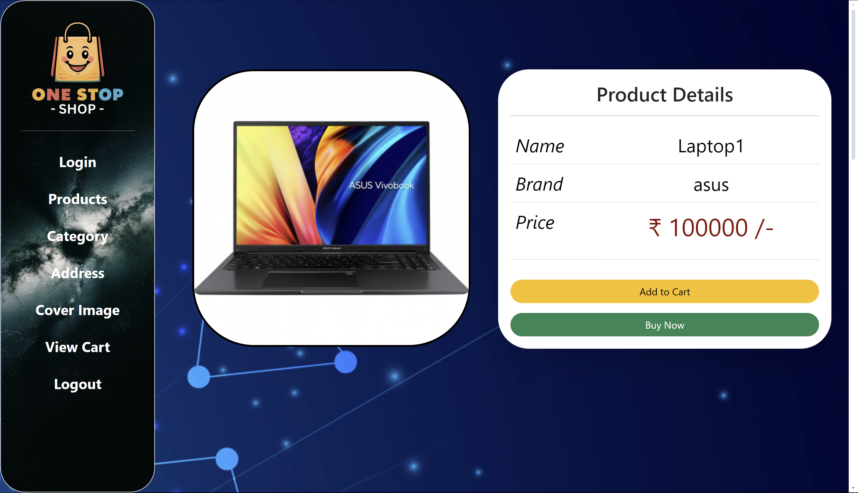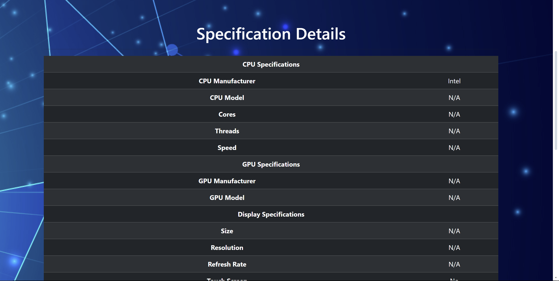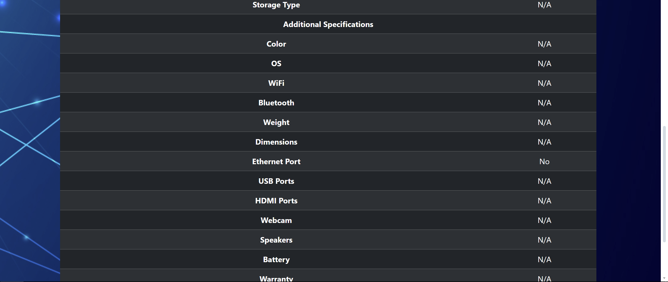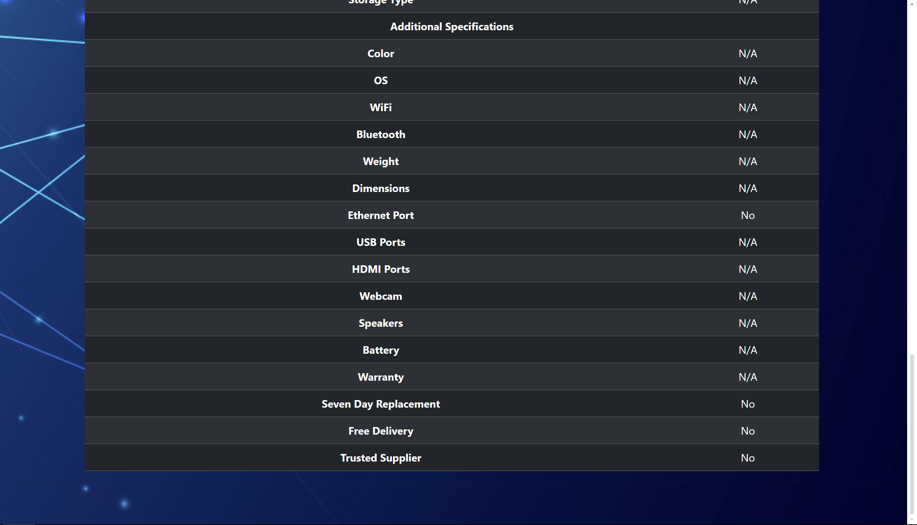

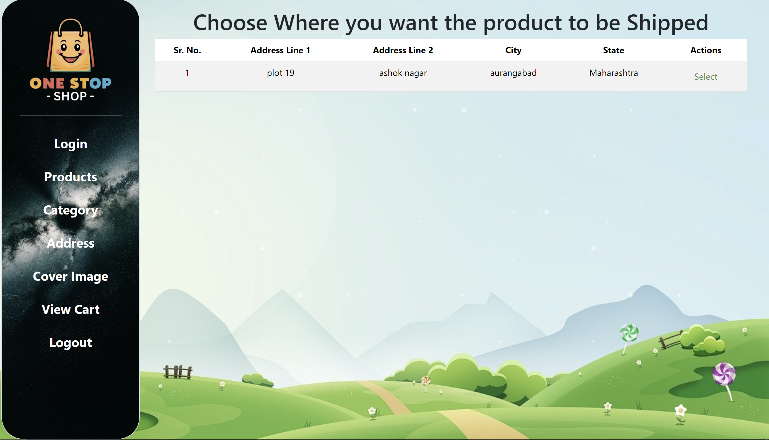

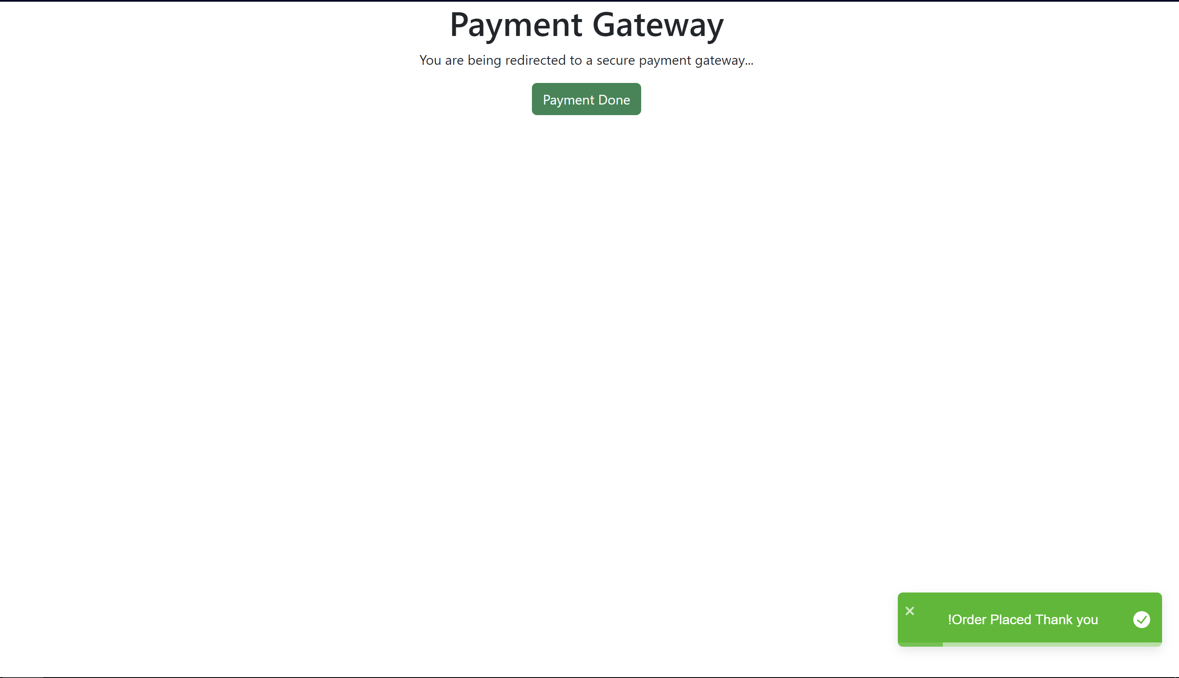

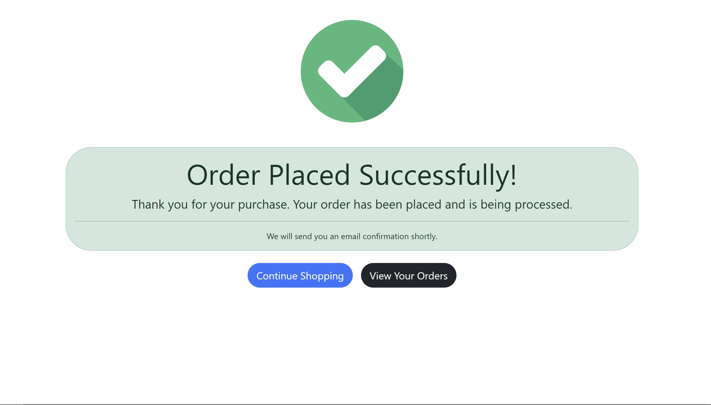

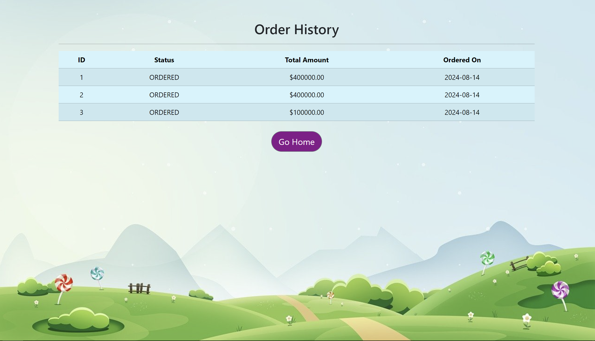

Banking:

**7.REFERENCES:**

<http://www.google.com>

[http://](http://www.xml101.com:8081/xml/)www.amazon.in

http://www.asus.com/

http://www.w3.org

http://www.wikipedia.org

http://www.dribble.com

http://www.stackoverflow.com